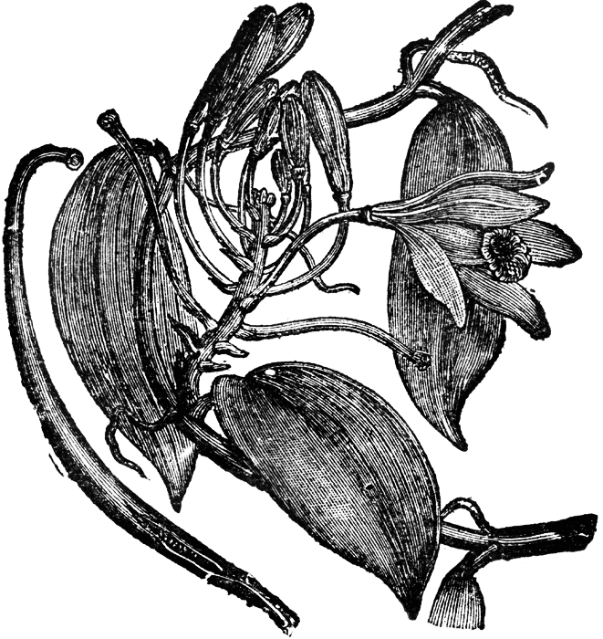
While you wait
Prosecco frizzante ‘Spago’ (125ml) £3.95
Spritzberry £5.50
raspberry, organic raspberry crush, fresh lemon, prosecco
Rose of Orient £5.50
damascene rose bubbly, pomegranate seeds, prosecco
White wine spritzer from £5.25
Classic G&T £4.35
Elderflower G&T £4.35
Elderflower Solstice £4.95
Gordon’s elderflower gin, apple & elderflower juice, fresh lemon

Nibbles (at £2.50 each)

Marinated olives
Roasted chilli broad beans
Dipping flat bread & balsamic olive oil
Crispy rosemary and sea salt flat bread
Creamy feta with smoked paprika

Our summer set
For the whole table to share
Herby falafel & tahini dip/ silky hummus/ tabbouleh/ burnt aubergine & ricotta gnocchi with labneh/ dipping bread & marinated olives/pickled vegetables/creamy feta & smoked paprika
Followed by … Main course of your choice £22.00 per person
(All steaks £2.50 supplement)

Starters
Homemade soup & bread £4.95
Lamb kidneys in pomegranate molasses, burnt pitta £6.50
Turkish lamb dumplings in Greek yoghurt, garlic & chickpea broth £6.95
Sardines wrapped in vine leaves, chilli jelly & sumac £6.95
Za’atar king prawns, cracked wheat, roasted lemon & tomato £6.95
Aubergine and ricotta gnocchi, burnt sage butter, frizzy lettuce £6.50
Courgettes fritters with lemon & dukkah dip, baby leaves, broad beans and pomegranate salad £6.50

Sides
Potato wedges/ seasonal vegetables/ bistro salad/ crusty bread or pitta @ £3.00 each

Meat
8oz Rump steak and garlic butter £15.95
Entrecote au Poivre peppercorn crusted 8oz sirloin steak £16.95
All above served with potato wedges, confit cherry tomato & baby leaves
Add grilled butterfly kidney to any steak for £1.25
Add pan-fried king prawns for £2.50
Sauces/butter: Béarnaise, Peppercorn, Port, Exmoor blue, Garlic butter £2.50
Lamb shank, green olives and preserved lemon tagine with tabbouleh, yoghurt and harissa £15.95
Belly of pork, bubble & squeak, pork jus & apple sauce £13.95
Confit duck, dauphinoise potatoes, French beans & port sauce £14.95
Fish
Grilled fillet of sea bass on red pepper, walnut & pomegranate sauce with burnt aubergines & warm potato salad £15.95
Roasted haddock on chickpeas, spinach & smoked paprika stew,
confit cherry tomatoes & roasted peppers £14.95
Fish & seafood broth with merguez sausage & crusty bread topped with muhammara (fish & seafood as available) £16.95
Vegetarian
Falafel salad with baked beets, feta, grilled peppers, olives & yoghurt dressing £9.50
Adele’s courgette salad with grilled courgettes, beans, feta, lemon & mint dressing topped with tempura courgettes stuffed with garlic cream cheese £11.95
Baked aubergine stuffed with Israeli couscous, herbs & pistachio nuts, topped with pomegranate on harissa labneh & fresh tomato & mint dressing £11.95
Desserts
All desserts are homemade @ £5.75

Baklava with pomegranate seeds and short of espresso (df)
Homemade meringue, whipped cream and seasonal fruit (gf)
(please ask for today flavour)
Belgian chocolate truffle, melon & chilli ice-cream (gf, df)
Warm rhubarb and ginger butterscotch pudding, clotted cream
Affogato £6.75
(2 scoops of vanilla ice-cream, a double shot of Tia Maria and a shot of espresso for the ultimate Italian after dinner hit!)

Selection of ice creams
Clotted cream vanilla, Strawberry, Double chocolate, Honeycomb, Toffee fudge, Mint choc chip
One scoop £2.30 Two scoops £3.60 Three scoops £4.70

Selection of local cheeses and biscuits
Ticklemore made near Totnes, Devon. The Sharpham Ticklemore goat is pasteurized, semi-hard cheese made with vegetable rennet
Sharpham Rustic semi-hard with moist creamy texture & a natural rind
Cornish Yarg light creamy, mould ripened cheese, wrapped in nettle leaves, has fresh slightly lemony taste and a unique flavour
Taw Valley cheddar traditional mature hard cheese with mellow taste and crumbly texture
Devon Blue a full fat, medium soft, creamy blue cheese
Cornish Brie rich and creamy with soft edible white rind
Two cheeses £5.95 Four cheeses £7.95 Six cheeses £10.95

Add a glass of Fine Ruby port £3.25 (50ml)
Taylor’s late vintage £4.50 (50ml)

Liquor coffees
All £5.50
Choose from any of the following spirits:
Courvoisier cognac
Bell’s, Red Label
Jameson’s
Baileys, Tia Maria, Cointreau

Beers and Ciders
Price per bottle/pint
Carlsberg (draft) £3.70
Korev (Cornish lager) £3.75
Exmoor Gold Ale (5%) £3.75
Otter Ale (3.6%) £3.65
Devon Cider (organic) £3.40

Spirits and liquors
Price per 25ml
Gordon’s gin £3.25
Gordon’s elderflower gin £3.25
Courvoisier cognac £3.30
Bell’s whisky £3.25
Red Label whisky £3.50
Jameson’s £4.25
Glenfiddich £4.25
Jack Daniels £3.25
Authentic Russian vodka £3.40
Baileys (50ml) £3.40
Tia Maria (50ml) £3.40

Beverages
Price per glass/bottle
Apple/Orange juice £1.95
Mineral still/ sparkling water £1.85/£3.50 Pepsi/ Diet Pepsi/ 7up £1.95
Luscombe soft drinks £2.75
Damascene rose bubbly, Madagascan vanilla soda, Cool ginger beer, Sicilian lemonade, Apple juice with elderflower, Wild elderflower bubbly, Raspberry crush

Coffees and Teas
Espresso/Double espresso £1.95/£2.25
Americano £2.25
Macchiato £1.95 Cappuccino £2.45
Café Latte £2.45
Café Mocha £2.65
Selection of teas £2.25
Breakfast, Earl Grey, Russian Caravan, Vanilla black, Green, Jasmine green
Selection of infusions £2.25
Oriental gingery lemon, Organic camomile, Organic peppermint, Organic Rooibos,
Summer fruit
Selection of fresh teas £2.50
Fresh Mint tea, Fresh Thyme tea

Note: At busy time, you might experience some delays, please bear with us as we do our utmost
to accommodate your requests and serve you as quickly as possible.
With regrets we have to apply charges for all the extras you wish to have unless it’s a substitute which we have agreed to provide.

